- Using Poisson regression with the social-demographic, regional and background (parents, economic occupation) control demonstrates that taking all into consideration the number of children is higher for Muslim than for non-Muslim population of Kazakhstan. See file “Poisson_muslim”. Here we also used 2 Muslim population categories: 1) those who specified their denomination as Muslim (muslim), 2) and additionally those who were assigned as Hindu (a big category concentrated in 1 region looks like a typo, by their characteristics they are close to Muslim) (muslim1). We see that after control the magnitude of religiosity os going slightly down, but still the effect is strong and significant.
- Using the question about values we calculated the indexes of family support (parental support and children support) – the answers on the questions about the situation that children and parents should support themselves are positive and strongly agree. Also we calculated the egalitarian index, demonstrating, the higher support of the role of women in society (work, education, family). There is a positive effect of family support on fertility and negative effect of egalitarian values. In first case control for the denomination leads to the disappearance of the significance for the family support and decline of it and magnitude of the effect of we recode the index variables to dichotomous, the negative effect of egalitarian values is still significant. See file “Poisson_values”. Looks like that family values are working more in case of Muslim population, while egalitarian values work for both cases.
- File “Indexes” shows that for Family and egalitarian values in both cases the Muslim population demonstrate the higher volume. Actually we constructed several other indexes, but they have no influence on fertility
- Religiosity as it is (see file “Poisson_relig”) slightly increase the number of children, but if we look at the religiousity by categories (5 ones from the lowest to highest) we see that the effect is non-linear, although all even slightly religious persons have fertility higher, that non-religious. If we look at the interaction effects we see that the effect is visible for Muslim, mainly for the most religious group, while for the non-Muslim groups there is no significant difference. And regardless the religiosity the Muslim group of population controlling for all covariates demonstrates the higher levels of fertility.
- Interaction effects for the families are following: for both groups the egalitarian values are decreasing number of children and family values increasing. Nevertheless the decline for the egalitarian values is simultaneous and in case of family support the effect for Muslim is higher, as for other denomination even almost non-visible

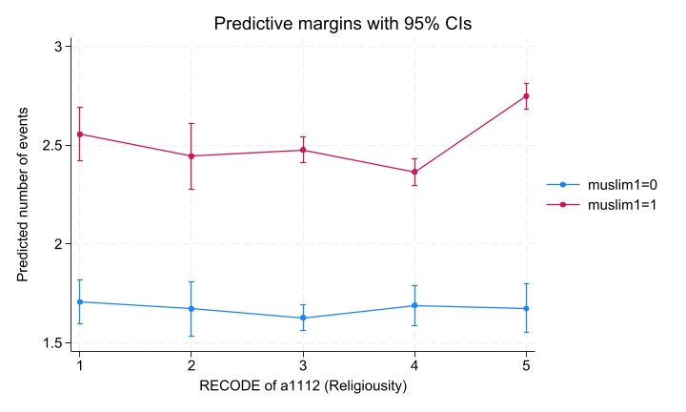
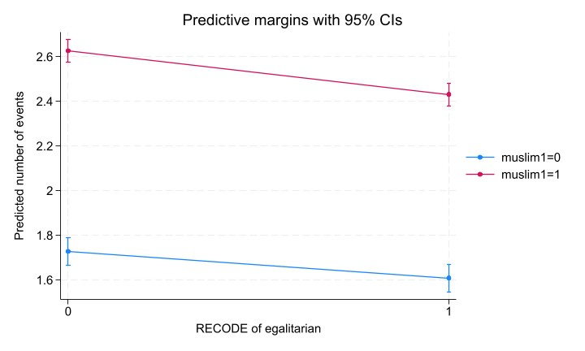
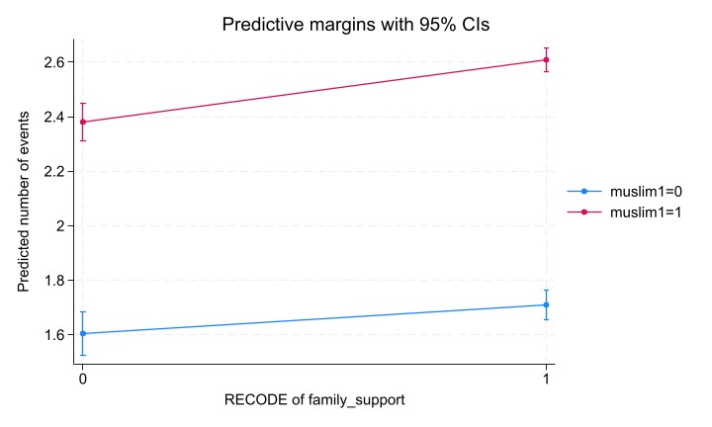

Further we wanted to see what the differences between denominations in birth orders. We could find that Muslim sub-group have higher fertility in all cases with the birth orders (the highest gap is for the 3rd birth). Nevertheless we can take a look if the values and religiosity play role here (see file “Cox_muslim”).
“Cox_rel” shows that linear religiousity influence positively only 1st child probability. Categorical religiousity also works mainly with 1 and someties with 3rd birth. Family support increase probability of 1 and 2nd births and after control for denomination the effect does not change, egalitarian values decrease the probabilities for the 1st and 2nd births (see “Cox_trad”).
Also apart from the situation with 1st child in non-religious population the Muslim have higher probability to give birth regardless the religiosity than non-Muslim.
